https://blog.csdn.net/weixin_41574643/article/details/80744147

**HttpServletRequest接收的是Json格式数据的解决办法**

置顶 2018年06月20日 13:55:57 [Caluzeman](https://me.csdn.net/weixin_41574643) 阅读数：1384 标签： [httpServlet](http://so.csdn.net/so/search/s.do?q=httpServlet&t=blog) 更多

个人分类： [httpservlet](https://blog.csdn.net/weixin_41574643/article/category/7745611)

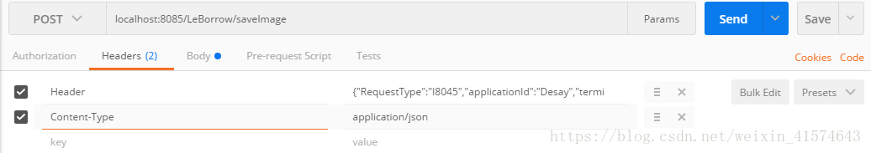

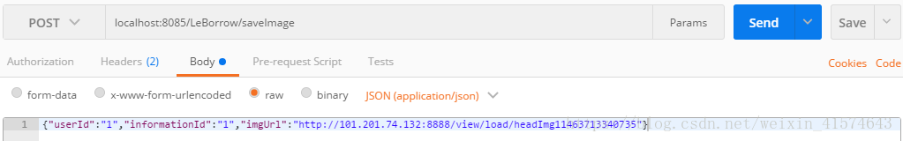

1. @Override
2. public boolean preHandle(HttpServletRequest request, HttpServletResponse response, Object handler)
3. throws Exception {
4. if (handler.getClass().isAssignableFrom(HandlerMethod.class)) {
5. Authentication Authentication = ((HandlerMethod) handler)
6. .getMethodAnnotation(Authentication.class);
7. *//如果没用Authentication这个注解标注的接口或者validate=false则直接通过*
8. if (Authentication == null
9. || Authentication.validate() == false) {
10. return true;
11. } else {
12. BufferedReader streamReader = new BufferedReader( new InputStreamReader(request.getInputStream(), "UTF-8"));
13. StringBuilder responseStrBuilder = new StringBuilder();
14. String inputStr;
15. while ((inputStr = streamReader.readLine()) != null)
16. responseStrBuilder.append(inputStr);
17. Map<String ,String> map = JSON.parseObject(Base64.decode(responseStrBuilder.toString()),Map.class);
18. String userToken = map.get("token");
19. log.debug("current token**************: " + userToken);
20. if (StringUtils.isBlank(userToken)) {
21. returnValue(response);
22. return false;
23. } else {
24. TokenTools tokenTools = new TokenTools();
25. if (!tokenTools.checkLoginInfo(userToken)) {
26. returnValue(response);
27. return false;
28. }
29. log.debug("You have logged in successfully!");
30. return true;
31. }
32. }
33. }else {
34. return true;
35. }
36. }

加红的代码是对Json串的处理